The Two-Face Protocol
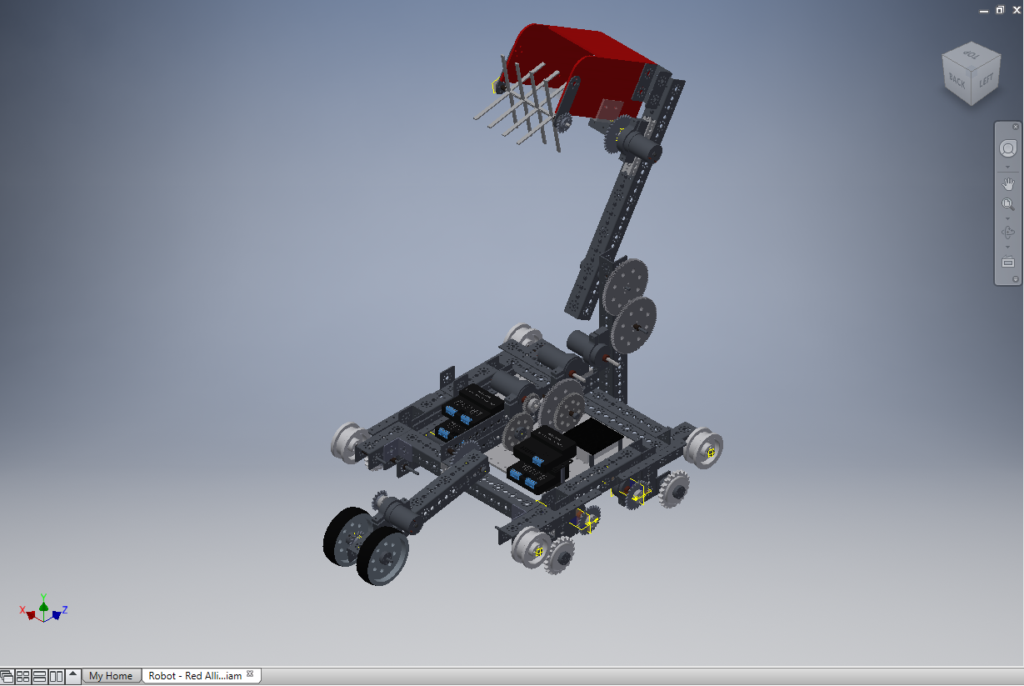
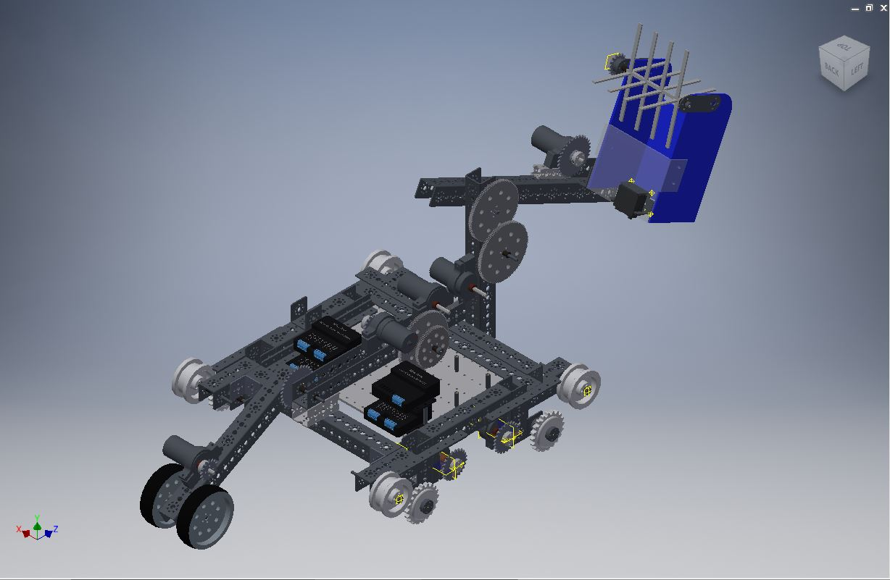
When we started this season out, we designed our robot witg the scoring bucket mounted on the left side of the robot. It was a very effective design and worked well. We but only for the red alliance. The reason for this is because if were are placed on the blue alliance, our arm is on the wrong side of the robot to score in the mountain goals.
Our solution to this was to design a mirror robot. We took our existing design, made a few measurement changes, and then modeled it in reverse. our robot would have two different arms, and two different wheelie bars.

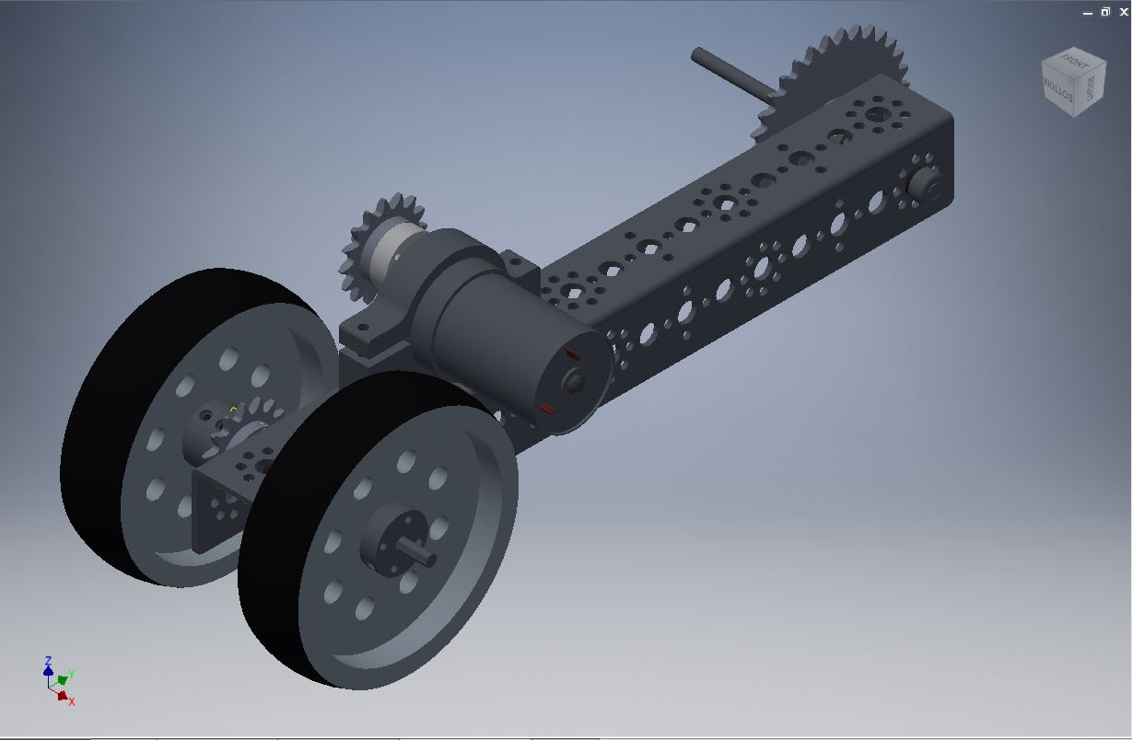
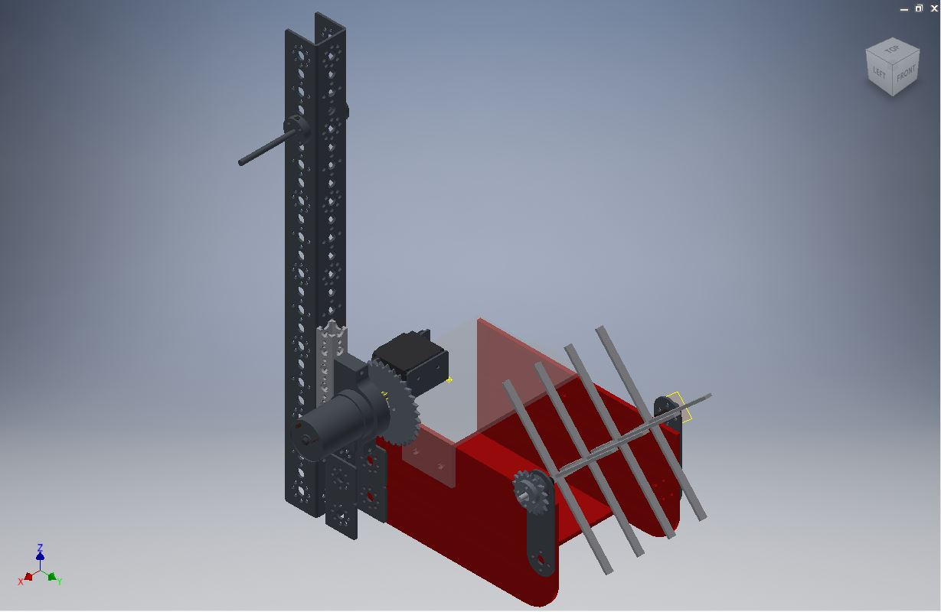
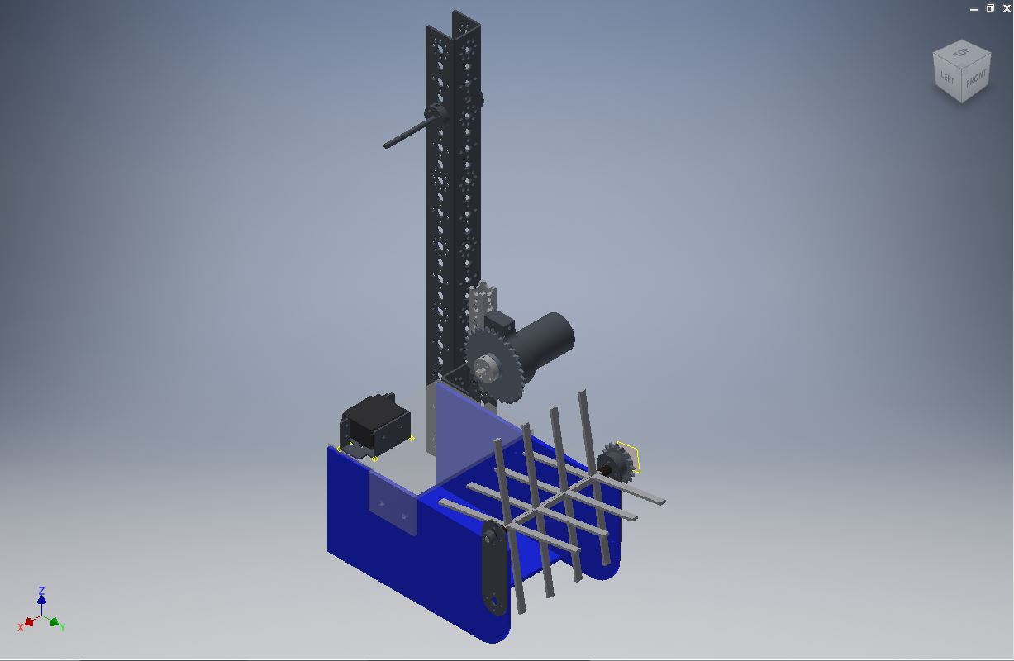
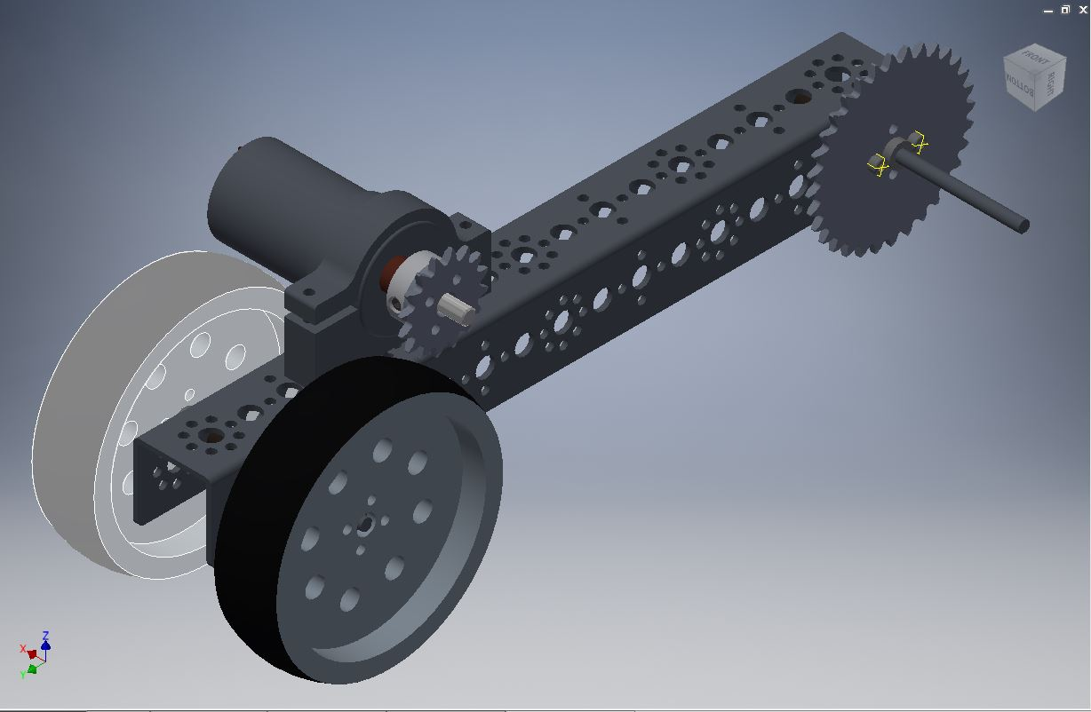
Depending on which alliance we are on for any given mach, we connect that corresponding arm and wheelie bar assembly. Since

CAD Modeling

These models, along with all other 3D models in the notebook, have been designed through Autodesk Inventor Professional 2016. Our team has in the past used programs such as PTC Creo Elements, and Google Sketchup. In fact, we were able to convert the existing PTC Tetrix parts files into parts readable by Autodesk. We chose to use Autodesk because it is a simpler program to learn, but is still a fully developed software. Autodesk has a free 3 year license for students, so we used that system to acquire licenses.

